1.

a) **Describe the differences between compressional (P) waves and shear (S) waves. What is the direction of particle motion for each? Which travels faster?**

Compressional (P) waves are longitudinal waves, where the particle displacement is parallel to the direction of wave propagation. Particles oscillate back and forth about their individual equilibrium. P waves have a faster velocity than S waves.

Shear (S) waves are transverse waves, where the particle displacement is perpendicular to the direction of wave propagation. The particles do not move along the wave, but oscillate up and down their individual equilibrium points as the wave passes. S waves have a slower velocity than P waves.

b) **Do the same for Rayleigh waves and Love waves:**

Love waves are a surface wave that moves the ground from side to side. They are confined the crust and produce entirely horizontal motion. They have the greatest velocity of surface waves.

Rayleigh waves are both longitudinal and transverse waves, in which the particles move in an elliptical path with the major axis perpendicular to the surface. On a model, the particles appear to be rolling along the direction of the wave. The magnitude of the particle motion decreases with depth from surface. Although Rayleigh waves are slower than Love waves, they cause they most shaking during earthquakes.

c) **What is a head wave, and under what conditions is it generated? When would you not expect to observe a head wave in a seismic survey?**

A head wave is a wave entering a relatively high-velocity medium whose incident and refracted angle is the critical angle. They occur due to a low to high velocity interface. The energy travels along the boundary at the higher velocity and is eventually refracted back into the upper medium at the critical angle.

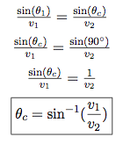

Using Snell’s law, we can see that if the lower layer, $v_{2}$, has a lower velocity than the above layer, $v_{1}$, a head wave will not be propagated because the sine function can never be valued greater than one.

2. **The results of a seismic refraction survey conducted in a desert region are given in the following figure. In this region, the near-surface geology is composed of lightly consolidated loess with the water table at some unknown depth. Answer the following:**

**a)** **Highlight the important wave arrivals on Figure 1 (direct wave, head wave, surface wave, etc)**

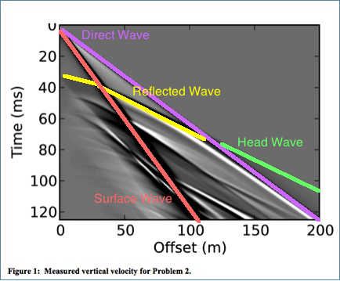

The direct wave is generated immediately at the source and propogates as a p-wave with a constant velocity, resulting in a linear plot. Head waves are created by waves striking the interferance at the critical angle, propogating along the interferance, then returning to the surface. The head waves surpasses the direct wave after the crossover distance. Like direct waves, surface waves appear immediately and continue with a constant velocity and do not interact with interface. The reflected wave appears later and interfer with the interace. These reflected waves act as harmonics and take on a hyperboic trajectory. Rocks are like optics, right?

**b)** **Estimate the slopes of the direct and head waves. What is the compressional wave velocity of the sediment above the water table, α1? What is the compressional wave velocity of the sediment below the water table, α2?**

The direct wave is the first to arrive within 100 meters from the source. I’m going to eyeball the values to approximate a slope, then fit a line to the data from the table since that seems like the logical thing to do.

Eyeballing the direct wave in the figure, the slope looks to be: $\frac{120ms}{200m}$, which equals 0.6 $\frac{ms}{m}$ or 0.6 $\frac{s}{km}$ since a millisecond is a measurement that makes me uneasy.

Now that’s still not really the velocity, so lets reflect the line in the figure across the line $f\left(x\right)=x$ to get the velocity of the sediment about the water, with the slope

$α_{1}=$ 1.666 $\frac{km}{s}$

For the velocity in the second layer, which contains the super fun water, we look at the velocity of the head wave. It was a little too inaccurate to eyeball so I used the data from the table like a civilized human being. The slope is 0.4030 $\frac{s}{km}$. To find the velocity of $α_{2}$ we take the inverse (exactly the same method as above) and find that

$α_{2}$ =2.48 $\frac{km}{s}$.

**c) Determine the crossover distance and intercept time of the head wave using Figure 1. At what depth is the water table located?**

Utilizing the graph provided and the data table, the crossover distance is around

Main Disk:Users:amandaatkinson:Desktop:Screen Shot 2013-10-24 at 10.26.31.pngThis is a little bit of sneak peak, but in problem 4a, we show that:

The water table is 223.0673 meters deep.

**d) Using the book program Refract, input your model (determined in parts b and c) and the first arrivals from the survey (given in Table 1). What is the RMS misfit of your model?**

Using the basic model based off the data the RMS misfit of my model is 7.70 ms

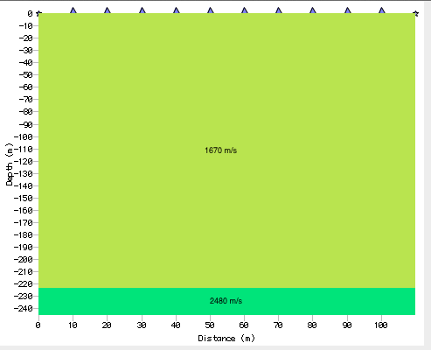

**e) Determine the best-fit model for the first arrivals using Refract, and plot the results.**

With an RMS misfit of 3.93 ms, my best model shows a thick upper layer with a high velocity.

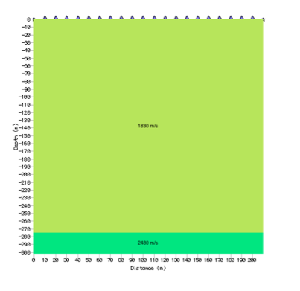

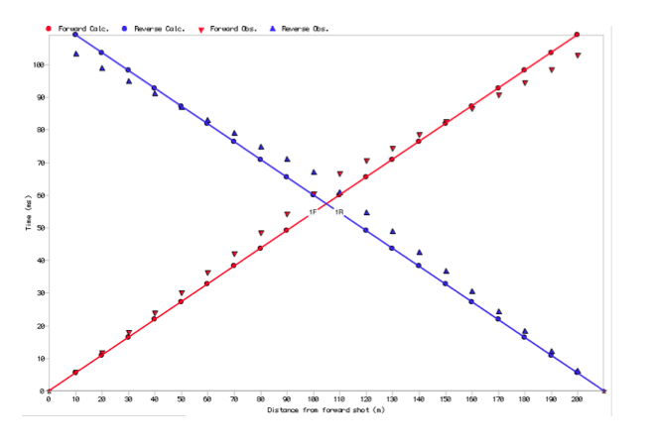

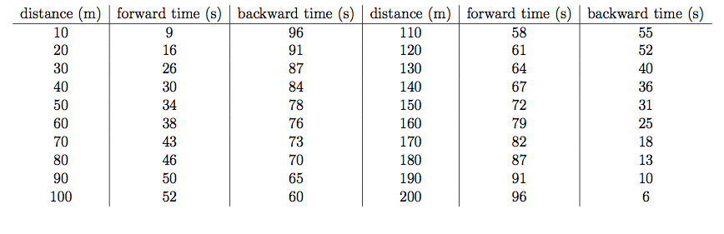**3. Another seismic refraction survey was conducted in the same desert region as in the previous problem. However, in this case the survey was taken near a stream located at X = -200m. The results for shots taken at the origin (X= 0m) and at the end of the string (X = 150m) are included in Figures 2 and 3. Answer the following:**

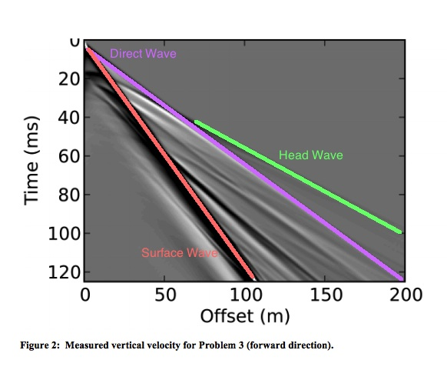

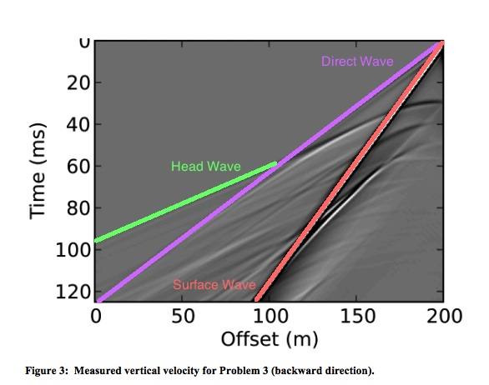

**b) Use Refract to determine the best-fit model for the refraction data. Provide a cross-section that shows your model and the survey geometry.**

Prior knowledge indicates that the crossover distances for the forward and backward models are not equal, which indicates that the upper layer is downdipping to the right to compensate for the difference in times.

My RMS misfit turns out to be 4.67 ms, my fitted model is shown below.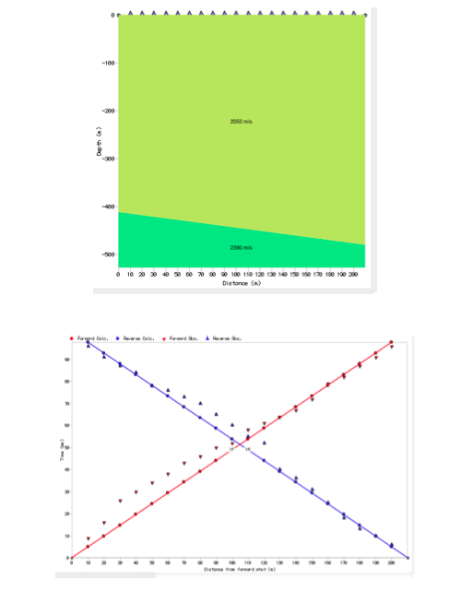

**4. Consider a seismic refraction survey conducted in an area characterized by**

**the three layer geologic profile given in Table 2. (Note: Do not use Refract to solve this problem.)**

**a)** **Determine the crossover distances for the direct wave, the head wave between layers 1 and 2, and the head wave between layers 2 and 3. Is it possible to detect the second layer using first-arrivals only? Why?**

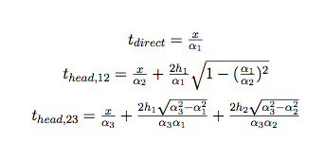For layers 1 and 2:

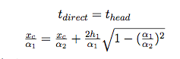The travel times are the same for the direct wave and the refracted wave at the crossover distance, $x_{c}$, which yields

Simplifying with algebra I didn’t really feel like typing up....

$$x_{c}=2h_{1}\sqrt{\frac{α_{2}+α_{1}}{α_{2}-α_{1}}}$$

Plugging in for Layers 1 and 2,

$$α_{1}=750 \frac{m}{s} α_{2}=1500\frac{m}{s} h_{1}=15m$$

$$x_{c,12}=2h\sqrt{\frac{α_{2}+α_{1}}{α_{2}-α_{1}}}=2\left(15m\right)\sqrt{\frac{1500\frac{m}{s} +750 \frac{m}{s} }{1500\frac{m}{s} -750 \frac{m}{s} }}≈51.96m$$

Layers 2 and 3,

$$α_{2}=1500\frac{m}{s} α_{3}=4000\frac{m}{s} h_{2}=5m$$

$$x_{c,23}=\frac{α_{1}α_{3}}{α_{3}-α_{1}}\left(\frac{2h_{1}\sqrt{α_{3}^{2}-α_{1}^{2}}}{α_{3}α_{1}}+\frac{2h_{2}\sqrt{α_{3}^{2}-α_{2}^{2}}}{α_{3}α_{2}}\right)=2h_{1}\sqrt{\frac{ν_{3}+ν_{1}}{ν_{3}-ν_{1}}}+\frac{2h_{2}ν_{1}}{ν_{2}}\sqrt{ν_{3}^{2}-ν_{2}^{2}}$$

$$=2\left(15m\right)\sqrt{\frac{4000\frac{m}{s} +750 \frac{m}{s} }{4000\frac{m}{s}-750 \frac{m}{s} }}+\frac{2(5m)(750 \frac{m}{s})}{1500\frac{m}{s}}\sqrt{({4000\frac{m}{s})}^{2}-({1500\frac{m}{s})}^{2}}=54.81m$$

We cannot use first arrivals to detect the second layer because there is a distance for either the direct wave or the head wave from the interface between the second and third layers to arrive before the head wave from the interface between the first and second layers.

**b)** **If the second layer is ignored in the interpretation of the survey data, how will this affect the final model?**

If the second layer ignored we might incorrectly model the first layer to have a faster velocity. We can confirm the true velocity with the direct wave arrival close to the source, so to correct for this error in the two-layered model, we could make the first layer thinner to keep travel time the same.

**c) What is the minimum thickness of the second layer, assuming the same velocities, such that it is possible to detect using seismic refraction?**

We need to find the minimum thickness, $x_{c,12}≤x_{c,23}$, so that the head wave from the 12 interface arrives first and the second layer is distinguishable.

$$x_{c,12}≤x_{c,23}$$

$$2h\sqrt{\frac{α_{2}+α_{1}}{α_{2}-α_{1}}}=\frac{α_{1}α_{3}}{α_{3}-α_{1}}\left(\frac{2h_{1}\sqrt{α_{3}^{2}-α_{1}^{2}}}{α_{3}α_{1}}+\frac{2h_{2}\sqrt{α_{3}^{2}-α_{2}^{2}}}{α_{3}α_{2}}\right)$$

So I plug in all values, which I decided not to type out because I preserving mental health, but I ended up with this equation:

$$51.96 m=923.1(.039+h_{2}\left(.001\right))$$

$$h_{2,min}≈24.26$$